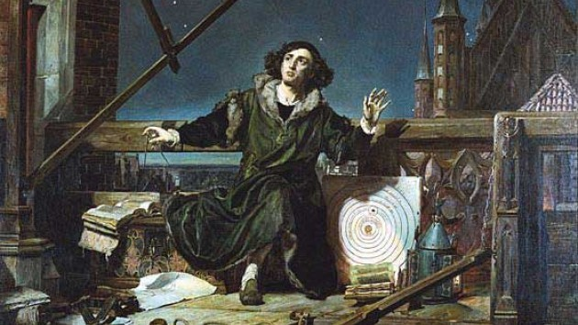
Polish astronomer and mathematician Nicolaus Copernicus fundamentally altered our understanding of science. Born on February 19, 1473, he popularized the heliocentric theory that all planets revolve around the Sun, ushering in the Copernican Revolution. But he was also a lifelong bachelor and member of the clergy who dabbled in medicine and economics.
He came from a family of merchants and clergy.
Some historians believe that Copernicus's name derives from Koperniki, a village in Poland named after tradesmen who mined and sold copper. The astronomer's father, also named Nicolaus Copernicus, was a successful copper merchant in Krakow. His mother, Barbara Watzenrode, came from a powerful family of merchants, and her brother, Lucas Watzenrode the Younger, was an influential Bishop. Two of Copernicus's three older siblings joined the Catholic Church, one as a canon and one as a nun.
He was a polyglot.
Growing up, Copernicus likely knew both Polish and German. When Copernicus's father died when he was around 10, Lucas Watzenrode funded his nephew's education and he started learning Latin. In 1491, Copernicus began studying astronomy, math, philosophy, and logic at Krakow University. Five years later, he headed to modern Italy's Bologna University to study law, where he likely picked up some Italian. During his studies, he also read Greek, meaning modern historians think he knew or understood five languages.

He wasn't the first person to suggest heliocentrism ...
Copernicus is credited with introducing heliocentrism -the idea that the Earth orbits the sun, rather than the sun orbiting the Earth.

He made contributions to economics.
He's known for math and science, but Copernicus was also quite the economist. In 1517, he wrote a research paper outlining proposals for how the Polish monarch could simplify the country's multiple currencies, especially in regard to the debasement of some of those currencies. His ideas on supply and demand, inflation, and government price-fixing influenced later economic principles such as Gresham's Law and the Quantity Theory of Money.
He was a physician (but he didn't have a medical degree).
After studying law, Copernicus traveled to the University of Padua so he could become a medical advisor to his sick uncle, Bishop Watzenrode. Despite spending two years studying medical texts and learning anatomy, Copernicus left medical school without a doctoral degree. Nevertheless, he traveled with his uncle and treated him, as well as other members of the clergy who needed medical attention.

He published his work on his deathbed.
Copernicus finishing writing his book explaining heliocentrism, De Revolutionibus Orbium Coelestium (On the Revolutions of Celestial Orbs), in the 1530s. When he was on his deathbed in 1543, he finally decided to publish his controversial work. According to lore, the astronomer awoke from a coma to read pages from his just-printed book shortly before passing away.

Archaeologists finally discovered his remains in 2008.
Although Copernicus died in 1543 and was buried somewhere under the cathedral where he worked, archaeologists weren't sure of the exact location of his grave. They performed excavations in and around Frombork Cathedral, finally hitting pay dirt in 2005 by finding part of a skull and skeleton under the church's marble floor, near an altar. It took three years to complete forensic facial reconstruction and compare DNA from the astronomer's skeleton with hair from one of his books, but archeologists were able to confirm that they had found his skeleton. Members of the Polish clergy buried Copernicus for a second time at Frombork in 2010.
THERE ARE MONUMENTS TO HIM AROUND THE WORLD